**Section 1**

**Aggregator of Local Physical Stores Database System**

IST 659: Project Implementation Report

**Vishwanath Hegde, Palaniappan**

Professor Hernando Hoyos

**05/09/2018**

**Section 2**

Project Summary

When it comes to purchasing products online people have unlimited number of choices and they also have a lot of visibility because the online companies constantly keep a track of the products available at their warehouse. However, this is not the case for local brick and mortar stores. Some products may be available at one store while other products may not be available there. Another point to consider is that in USA where people of diverse background reside, it is very difficult for them to find the products which are related to their country of origin. Buying such products online would be expensive because of the delivery charges incurred. Therefore, it would be in the best interest of customers to use a platform that gives them information about their interested products near their surrounding so that they can physically go there and shop.

The data of products available at local stores is inadequate. There may be some local stores that keep data while others don’t. Some stores that have data may not have specific data for users to make informed decision. Currently data about products available at local stores is scarce, inconsistent and untrustworthy. Moreover, these stores rely on their social media presence and offline options to inform customers about their offers and discounts. While this gives a little visibility, however it may not be sufficient because of the lack of flexibility in social media. This inadequacy in product data is also problematic for customers as they have no way other than taking time off and physically visiting the store or calling the local store. Both the options are time consuming.

For the physical stores who are already struggling against ecommerce giants such as Amazon Grocery and Walmart, our project would provide a useful platform that lets them get visibility and reach out to customers through offers and discount coupons

The proposed project will provide users with information about types of products available in local stores along with their prices and description. It will also provide local stores with information regarding consumer behavior and address so that they can serve their customers better through offers and discounts.

An aggregator platform that lists products available would make it easier for customers to save time, make informed decisions and plan their trip to the store accordingly. The platform would also help local stores get customer data and develop plans according to insights provided in the data. The database needs to be constantly updated using inputs given by the local stores so that customers get accurate data every time they access the platform.

This database will power an online platform. The users will be customers and database administrator. For simplicity the administrator will provide information to local stores.

**Section 3**

**Entity and Attribute Table**

|  |  |  |
| --- | --- | --- |
|  | Objects | Description |
| 1. | **Customer Preference** | What product type/origin customer prefers |
| a. | Preference ID | (PK) Identifies the preference category |
| b. | Customer ID | (FK) Identifies the customer |
| c. | Preference Type | The type of product |
|  |  |  |
| 2. | **Customers** | Customer Information |
| a. | Customer ID | (PK) Identifies customer |
| b. | First Name | First Name of customer |
| c. | Last Name | Last Name of customer |
| d. | Customer Apt No | Apartment number of customer |
| e. | Customer Street Address | Street address of customer |
| f. | Customer City | City where customer lives |
| g. | Customer State | State where customer lives |
| h. | Customer Pin Code | Pincode of the customer |
| i. | Customer phone number | Customers phone number |
| j. | Customer email address | Customers email ID |
|  |  |  |
| 3. | **Item Viewed** | What items customer viewed. This data can be recorded through Google Analytics. The data then will be fed into the database system |
| a. | View ID | (PK)Identifies views |
| b. | Customer ID | (FK)Identifies customer |
| c. | Product ID | (FK)Identifies product |
| d. | Date Viewed | Date the item was viewed |
| e. | Time Viewed | Time the item was viewed |
|  |  |  |
| 4. | **Local Stores** | Local store information |
| a. | Local Store ID | (PK) Identifies local stores |
| b. | Local Store Name | Name of the local store |
| c. | Local Store Street Address | Street Address of local store |
| d. | Local Store city | City where the store is located |
| e. | Local Store State | State where the store is located |
| f. | Local Store Pincode | Pincode of the local store |
| g. | Local Store phone number | Phone number of local store |
| h. | Local Store email | Email address of local store |
|  |  |  |
| 5. | **Product** | Product information |
| a. | Product ID | (PK)Identifies product |
| b. | Local Store ID | (PK)(FK)Identifies local store |
| c. | Product name | Name of the product |
| d. | Product type | Type of product |
| e. | Product country of origin | Where Is the product made from |
| f. | Product Description | Brief description of product |
| g. | Product Price | Price of product |
|  |  |  |
| 6. | **Coupon** | Coupon Information |
| a. | Coupon ID | (PK)Identifies coupon |
| b. | Local Store ID | (FK)Identifies local store |
| c. | Product ID | (FK)Identifies product |
| d. | Coupon Name | Name of the coupon |
| e. | Coupon Type | Type of coupon |
| f. | Coupon Description | Description of coupon |
| 7 | **Local Store Products** | Entity will list about a local stores product and quantity |
|  | Local Store Product ID | (PK) Identifies product present in a particular local store |
|  | Local Store ID | Identifies local stores |
|  | Product ID | Identifies product |
|  | Product Quantity | Quantity of products present in local store |
| 8 | **Customer Preference** | Preference of customers in terms of country of products they like |
|  | Customer Preference Type ID | Identifies customer preference |
|  | Customer Preference Type | From which country does the customer prefer products from eg: Indian, American, Chinese |
| 9 | **Coupon instance** | Creates one instance of coupon for each customer |
|  | Coupon Unique Identifier | Is created whenever customer avails a coupon |
|  | Coupon ID | Identifies coupon |
|  | Customer ID | Identifies customer |

**Section 3.1**

**Entity Relationship Diagram (ERD)**

**Aggregator of Local Physical Store Entity Relationship Diagram**

**A screenshot of a computer

Description generated with very high confidence**

**Business Rules**

1. Each user needs to have a unique email
2. Every store needs to have an address in Syracuse
3. Every store needs to have an item to sell
4. Every Product should have a monetary value
5. One customer can have many coupon but a specific coupon can be availed by only 1 customer.

**Section 4**

**Database System Architecture**

The database system infrastructure used is based on a client-server model. SQL Server is used as the database engine and Access is used as the interface design tool. Data is inserted, deleted, updated, and queried from the SQL Server database with the help of forms on Access. Useful data stored on the SQL Server database can also be viewed with the help of reports generated through Access.

**Section 5**

**SQL Script for Creating Tables and Inserting Sample Data**

**Create Tables**

**Customers**

CREATE TABLE Customers (

CustomerID int IDENTITY(1,1) PRIMARY KEY,

FirstName varchar(255) Not Null,

LastName varchar(255) Not Null,

House_No Char(10) Not null,

Street varchar(50) not null,

City varchar(50) not null,

State_Name char(2) not null,

Zip_code char(6) not null,

Phone_No char(12) not null,

Email_No varchar(50) not null unique

);

**Products**

CREATE TABLE Product (

ProductID int IDENTITY(1,1) PRIMARY KEY,

ProductName varchar(50) not null,

ProductType varchar(15) not null,

ProductCountry varchar(60) not null,

ProducyDescription varchar(200),

Price decimal(6,2) not null CHECK (Price <> 0.00),

CONSTRAINT CHK_ProdType CHECK (ProductType in ('Groceries', 'Cosmetics', 'Electronics', 'Furnitures', 'Accessories'))

);

**Customer Preference**

CREATE TABLE CustomerPreference (

PreferenceID int IDENTITY(1,1) PRIMARY KEY,

CustomerID int not null foreign key references Customers(CustomerID),

PreferenceType varchar(15) CHECK (PreferenceType in ('American', 'Indian', 'Mexican', 'Chinese', 'Italian'))

);

**Item Viewed**

create table ItemViewed (

ViewID int identity(1,1) primary key,

CustomerID int not null foreign key references Customers(CustomerID),

ProductID int not null foreign key references Product(ProductID),

DateViewed date not null,

TimeViewed time not null,

);

**Local Stores**

create table LocalStores (

LocalStoreID int identity(1,1) primary key,

StoreName varchar(50) not null,

Street varchar(60) not null,

City varchar(25) not null Check (City = 'Syracuse'),

StoreState char(2) not null,

Zip char(6) not null,

PhoneNumber char(12) not null,

Email varchar(25) not null

);

**Local Store Products**

create table LocalStoreProducts (

LocalStoreProductID int identity(1,1) primary key,

ProductID int not null foreign key references Product(ProductID),

LocalStoreID int not null foreign key references LocalStores(LocalStoreID),

ProductQuantity int

);

**Coupon**

create table Coupon (

CouponID int identity(10000000,1) primary key,

LocalStoreID int not null foreign key references LocalStores(LocalStoreID),

ProductID int not null foreign key references Product(ProductID),

CouponName varchar not null,

CouponType varchar not null,

CouponDescription varchar

);

**Coupon Instance**

create table CouponInstance (

CouponUniqueIdentitifier int identity(1,1) not null primary key,

CouponID int not null foreign key references Coupon(CouponID),

CustomerID int not null foreign key references Customers(CustomerID)

);

**6b – Insert Sample Data**

--inserting values to customers tables

insert into Customers

values ('Palani', 'Muthu', '1046', 'Lancaster Ave', 'Syracuse', 'NY', '13210', '315-278-2287', 'pmuthukk@syr.edu');

insert into Customers

values ('Viswanath', 'Hedge', '1020', 'Westcott', 'Syracuse', 'NY', '13210', '315-678-6754', 'vhedge@syr.edu');

insert into Customers

values ('Vaisali', 'Sundar', '1046', 'Lancaster Ave', 'Syracuse', 'NY', '13210', '315-278-2288', 'vsundar@syr.edu');

insert into Customers

values ('Praveen', 'Kumar', '1027', 'Dewitt St', 'Syracuse', 'NY', '13210', '315-876-6798', 'pkumar@syr.edu');

insert into Customers

values ('Prasan', 'Krishnan', '1020', 'Ackerman Ave', 'Syracuse', 'NY', '13210', '315-278-1278', 'pkrishnan@syr.edu');

insert into Customers

values ('Shreyas', 'Sambumurthy', '323', 'Lexington Ave', 'Syracuse', 'NY', '13210', '315-786-5634', 'ssambu@syr.edu');

insert into Customers

values ('Rishi', 'Krishnan', '822', 'Westcott Street', 'Syracuse', 'NY', '13210', '315-123-5674', 'rkrishnan@syr.edu');

insert into Customers

values ('Dharani', 'Dharan', '323', 'Lexington Ave', 'Syracuse', 'NY', '13210', '315-122-4323', 'ddharan@syr.edu');

insert into Customers

values ('Dinesh', 'Ramaswamy', '142', 'Sumner Ave', 'Syracuse', 'NY', '13210', '315-278-0000', 'sramasw@syr.edu');

insert into Customers

values ('Arjun', 'Kalyanasundaram', '323', 'Walnut Pl', 'Syracuse', 'NY', '13212', '315-111-5322', 'akalyanam@syr.edu');

select * from Customers;

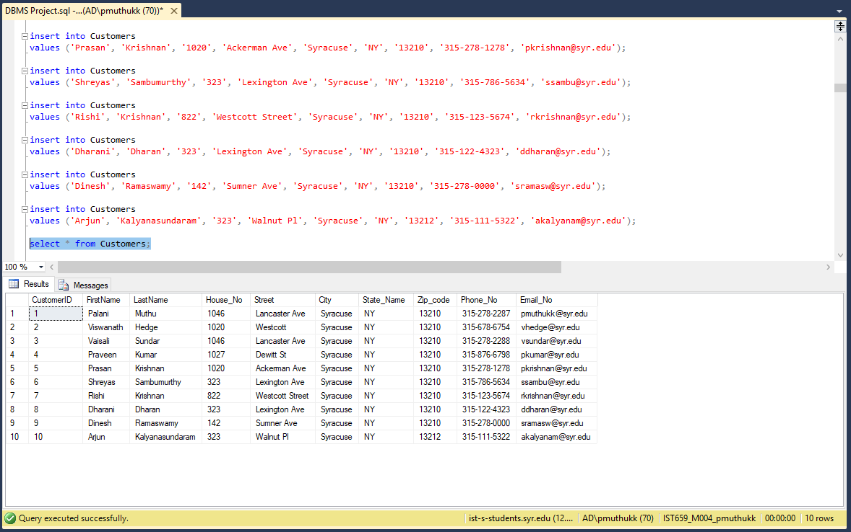

--Inserting values to Local Stores table

insert into LocalStores

values ('India Bazaar', '4471 E Genesse St', 'Syracuse', 'NY', '13214', '315-449-4400', 'indiabazaar@gmail.com');

insert into LocalStores

values ('Lancaster Market', '1007 Lancaster Ave', 'Syracuse', 'NY', '13210', '315-472-4661', 'lancastermarket@gmail.com');

insert into LocalStores

values ('Walmart', '6438 Basile Rowe', 'East Syracuse', 'NY', '13057', '315-434-9873', 'walmartsyr@gmail.com');

insert into LocalStores

values ('Tops', '620 Nottingham Rd', 'Syracuse', 'NY', '13210', '315-446-1652', 'Topssyr@gmail.com');

insert into LocalStores

values ('Target', 'Fairmount Fair', 'Syracuse', 'NY', '13210', '315-233-0600', 'Target@gmail.com');

insert into LocalStores

values ('BestBuy', '9090 Destiny USA', 'Syracuse', 'NY', '13204', '315-426-1588', 'bestbuy@gmail.com');

select * from LocalStores;

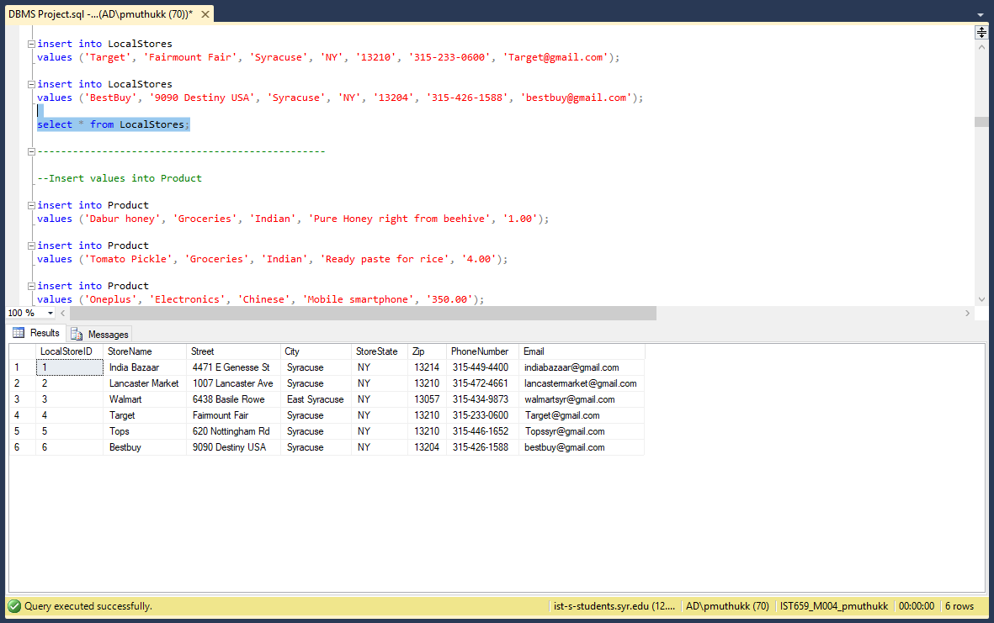

-------------------------------------------------

--Insert values into Product

insert into Product

values ('Dabur honey', 'Groceries', 'Indian', 'Pure Honey right from beehive', '1.00');

insert into Product

values ('Tomato Pickle', 'Groceries', 'Indian', 'Ready paste for rice', '4.00');

insert into Product

values ('Oneplus', 'Electronics', 'Chinese', 'Mobile smartphone', '350.00');

insert into Product

values ('SoundPeats 2XL', 'Electronics', 'Chinese', 'Bluetooth Wireless headset', '20.00');

insert into Product

values ('L.A Girl Eyeshadow', 'Cosmetics', 'American', 'Magnetic case includes mirror and double-sided eyeshadow applicator', '7.99');

insert into Product

values ('Miswak Toothpaste', 'Cosmetics', 'Indian', 'Ayurvedics Totth Paste', '2.00');

insert into Product

values ('Beef Hardshell Tacos', 'Groceries', 'Mexican', 'traditional mexican taco', '5');

insert into Product

values ('iPad Mini', 'Electronics', 'American', 'iPad with Retina Display', '249.00');

insert into Product

values ('Barilla Pastina Pasta', 'Groceries', 'Italian', 'Al dente perfection in 6-7 minutes', '2.07');

insert into Product

values ('Layered Hoop Earrings', 'Accessories', 'American', 'A pair of high-polish layered hoop earrings featuring textured and etched finishes and omega closures.', '3.90');

insert into Product

values ('Marino’s Leather Belt', 'Accessories', 'American', 'HIGH QUALITY CRAFTMANSHIP. Marino’s genuine leather belts are highly constructed for a longer endurance and better upholding. HAND WASHABLE', '25.99');

insert into Product

values ('Charlies Potato', 'Groceries', 'American', 'Raw potatoes', '5.00');

select * from Product; 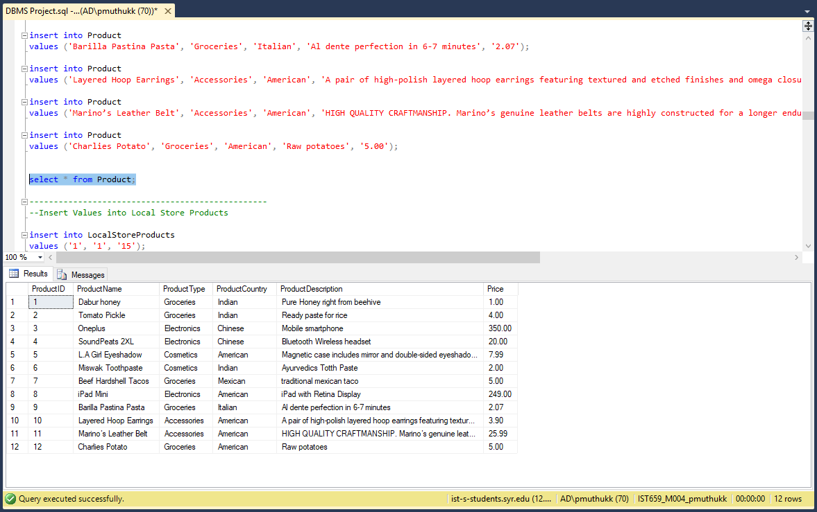

-------------------------------------------------

--Insert Values into Local Store Products

insert into LocalStoreProducts

values ('1', '1', '15');

insert into LocalStoreProducts

values ('1', '3', '35');

insert into LocalStoreProducts

values ('1', '4', '20');

insert into LocalStoreProducts

values ('2', '1', '22');

insert into LocalStoreProducts

values ('2', '1', '22');

insert into LocalStoreProducts

values ('3', '3', '10');

insert into LocalStoreProducts

values ('3', '6', '23');

insert into LocalStoreProducts

values ('4', '6', '8');

insert into LocalStoreProducts

values ('5', '2', '10');

insert into LocalStoreProducts

values ('5', '3', '5');

insert into LocalStoreProducts

values ('6', '1', '3');

insert into LocalStoreProducts

values ('7', '5', '3');

insert into LocalStoreProducts

values ('7', '4', '4');

insert into LocalStoreProducts

values ('7', '3', '2');

insert into LocalStoreProducts

values ('8', '3', '2');

insert into LocalStoreProducts

values ('8', '6', '1');

insert into LocalStoreProducts

values ('9', '3', '2');

insert into LocalStoreProducts

values ('9', '4', '4');

insert into LocalStoreProducts

values ('9', '5', '2');

insert into LocalStoreProducts

values ('10', '3', '3');

insert into LocalStoreProducts

values ('11', '3', '4');

insert into LocalStoreProducts

values ('12', '3', '9');

insert into LocalStoreProducts

values ('12', '4', '4');

insert into LocalStoreProducts

values ('12', '5', '5');

select * from LocalStoreProducts;

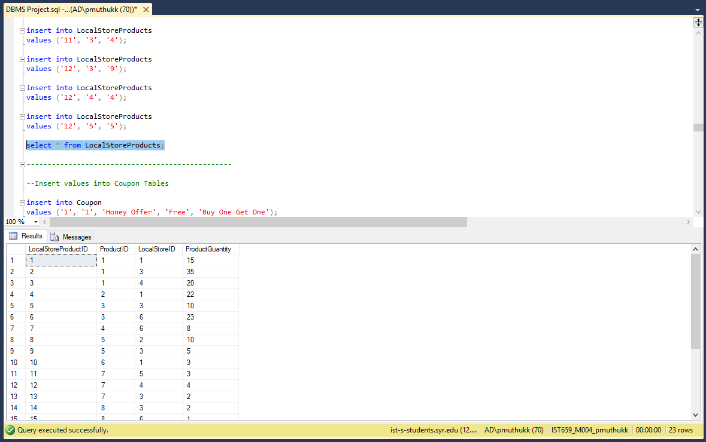

-------------------------------------------------

--Insert values into Coupon Tables

insert into Coupon

values ('1', '1', 'Honey Offer', 'Free', 'Buy One Get One');

insert into Coupon

values ('3', '3', 'Save on Mobile', 'Discount', '20% offer');

insert into Coupon

values ('3', '6', 'Save on Mobile', 'Discount', '20% offer');

insert into Coupon

values ('6', '8', 'iPad Summer Sale', 'Discount', '30% offer');

insert into Coupon

values ('3', '8', 'iPad Summer Sale', 'Discount', '30% offer');

select * from Coupon;

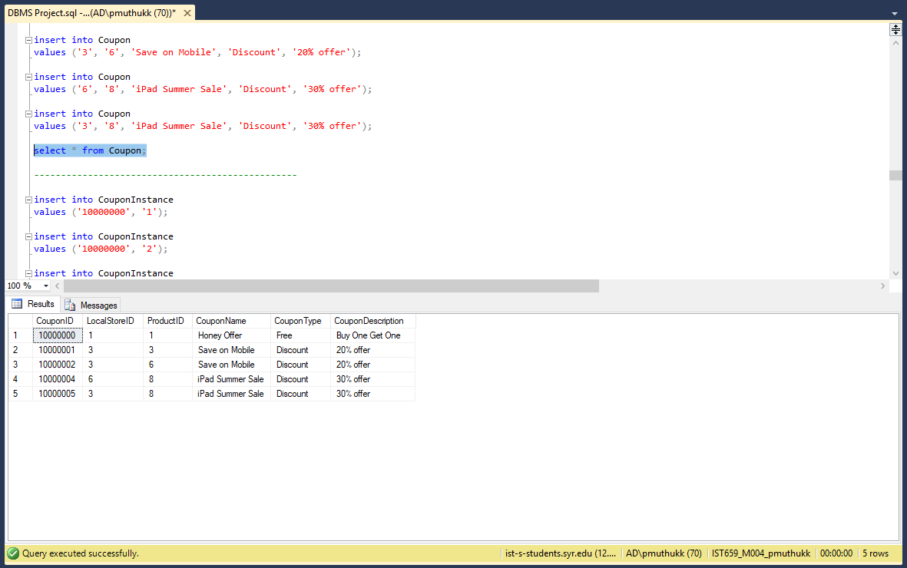

-------------------------------------------------

insert into CouponInstance

values ('10000000', '1');

insert into CouponInstance

values ('10000000', '2');

insert into CouponInstance

values ('10000000', '6');

insert into CouponInstance

values ('10000001', '3');

insert into CouponInstance

values ('10000001', '4');

insert into CouponInstance

values ('10000002', '8');

insert into CouponInstance

values ('10000002', '9');

insert into CouponInstance

values ('10000002', '1');

insert into CouponInstance

values ('10000002', '2');

insert into CouponInstance

values ('10000004', '2');

insert into CouponInstance

values ('10000004', '3');

insert into CouponInstance

values ('10000004', '10');

insert into CouponInstance

values ('10000004', '8');

insert into CouponInstance

values ('10000004', '7');

insert into CouponInstance

values ('10000005', '5');

insert into CouponInstance

values ('10000005', '10');

insert into CouponInstance

values ('10000005', '7');

insert into CouponInstance

values ('10000005', '4');

insert into CouponInstance

values ('10000005', '2');

select * from CouponInstance;

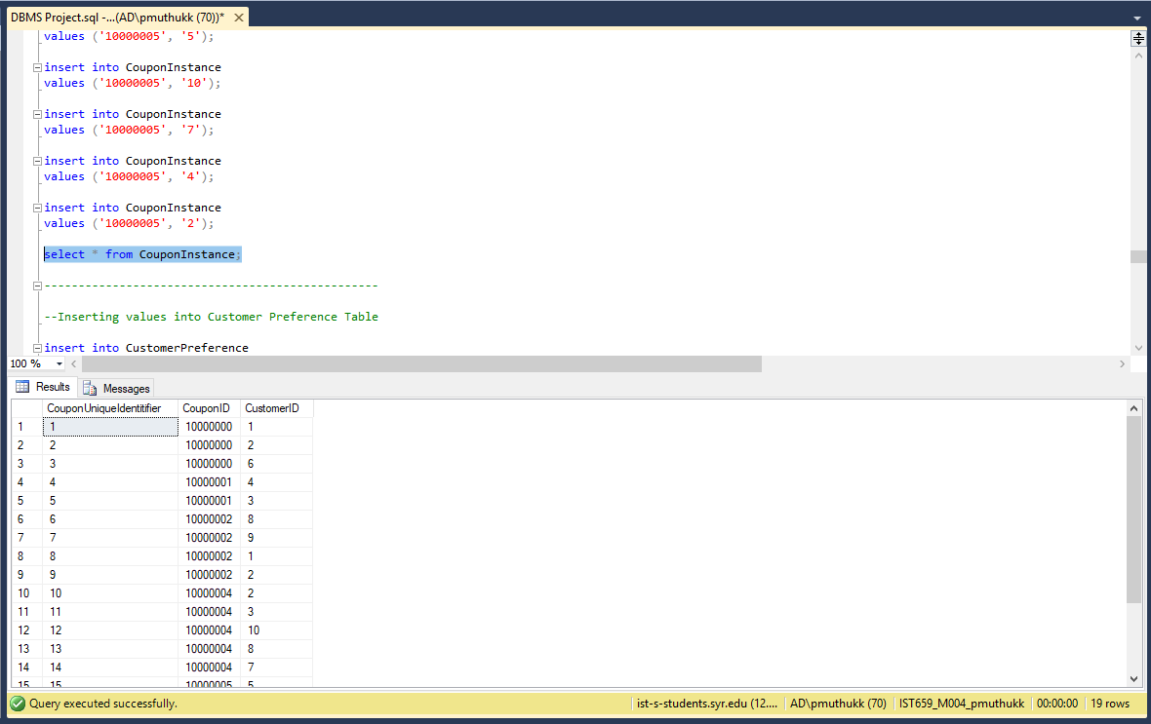

-------------------------------------------------

--Inserting values into Customer Preference Table

insert into CustomerPreference

values ('1', 'Indian');

insert into CustomerPreference

values ('1', 'American');

insert into CustomerPreference

values ('2', 'Italian');

insert into CustomerPreference

values ('3', 'Mexican');

insert into CustomerPreference

values ('3', 'Indian');

insert into CustomerPreference

values ('4', 'American');

insert into CustomerPreference

values ('4', 'Indian');

insert into CustomerPreference

values ('4', 'Chinese');

insert into CustomerPreference

values ('5', 'Chinese');

insert into CustomerPreference

values ('6', 'American');

insert into CustomerPreference

values ('6', 'Mexican');

insert into CustomerPreference

values ('7', 'Indian');

insert into CustomerPreference

values ('7', 'Chinese');

insert into CustomerPreference

values ('8', 'Italian');

insert into CustomerPreference

values ('8', 'American');

insert into CustomerPreference

values ('9', 'Mexican');

insert into CustomerPreference

values ('10', 'Italian');

insert into CustomerPreference

values ('10', 'Indian');

select * from CustomerPreference;

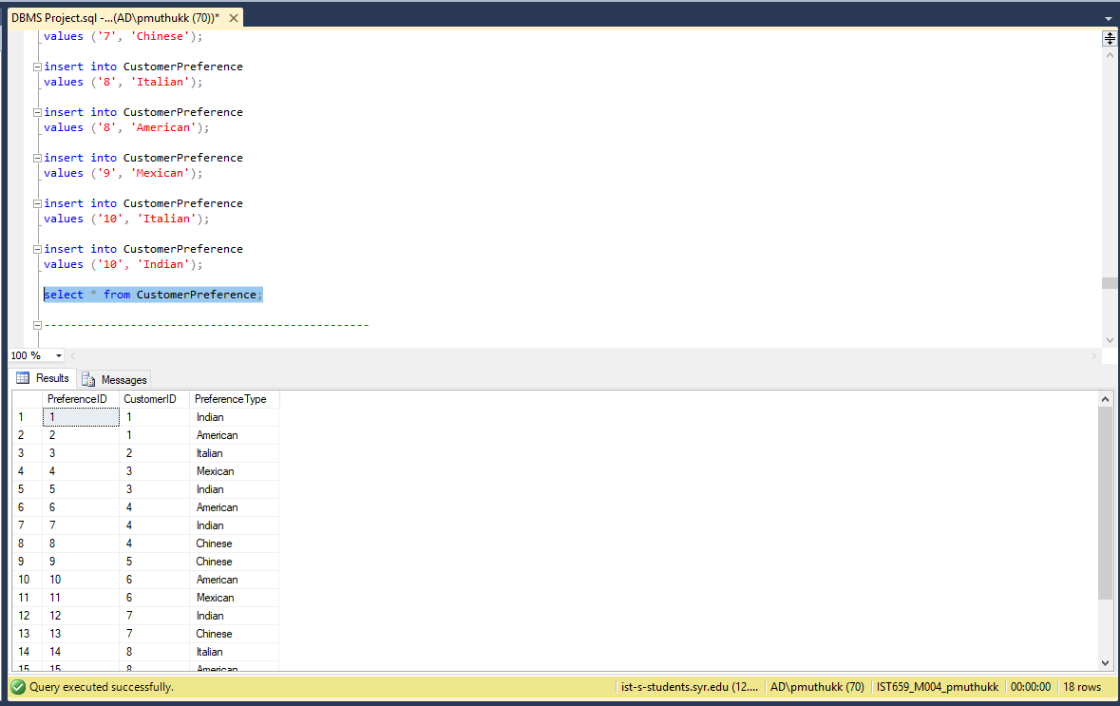

-------------------------------------------------

--Insert Items into the Item Viewed Table

select * from ItemViewed;

insert into ItemViewed

values ('1','2','04-13-2018','12:20:34')

insert into ItemViewed

values ('1','3','04-14-2018','14:20:34')

insert into ItemViewed

values ('1','4','04-18-2018','10:20:35')

insert into ItemViewed

values ('2','3','04-20-2018','8:23:56')

insert into ItemViewed

values ('3','6','05-19-2018','6:29:30')

insert into ItemViewed

values ('4','2','01-23-2018','9:23:40')

insert into ItemViewed

values ('4','6','04-20-2018','15:13:30')

insert into ItemViewed

values ('2','7','04-21-2018','14:13:23')

insert into ItemViewed

values('2','7','04-13-2018','18:13:25')

insert into ItemViewed

values('5','10','02-16-2018','9:13:25')

insert into ItemViewed

values('5','7','04-13-2018','7:13:25')

insert into ItemViewed

values('6','11','04-01-2018','10:13:25')

insert into ItemViewed

values('7','9','04-21-2018','10:22:25')

insert into ItemViewed

values('8','9','03-21-2018','8:22:25')

insert into ItemViewed

values('9','9','04-11-2018','19:22:25')

insert into ItemViewed

values('10','9','03-21-2018','21:22:25')

insert into ItemViewed

values('9','9','04-09-2018','20:22:25')

Select * from ItemViewed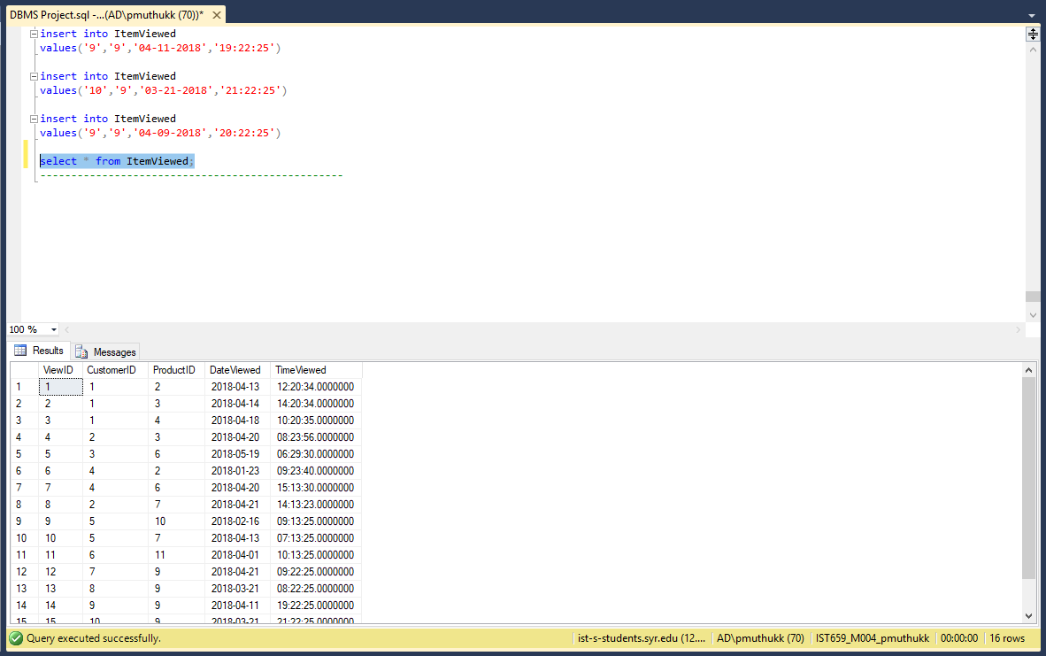

-------------------------------------------------

**Section 6**

**SQL Statements for Answering Major Data Questions.**

**Data Questions**

1. How many products are from USA

--1) No. of products from America

select * from Product where ProductCountry='American';

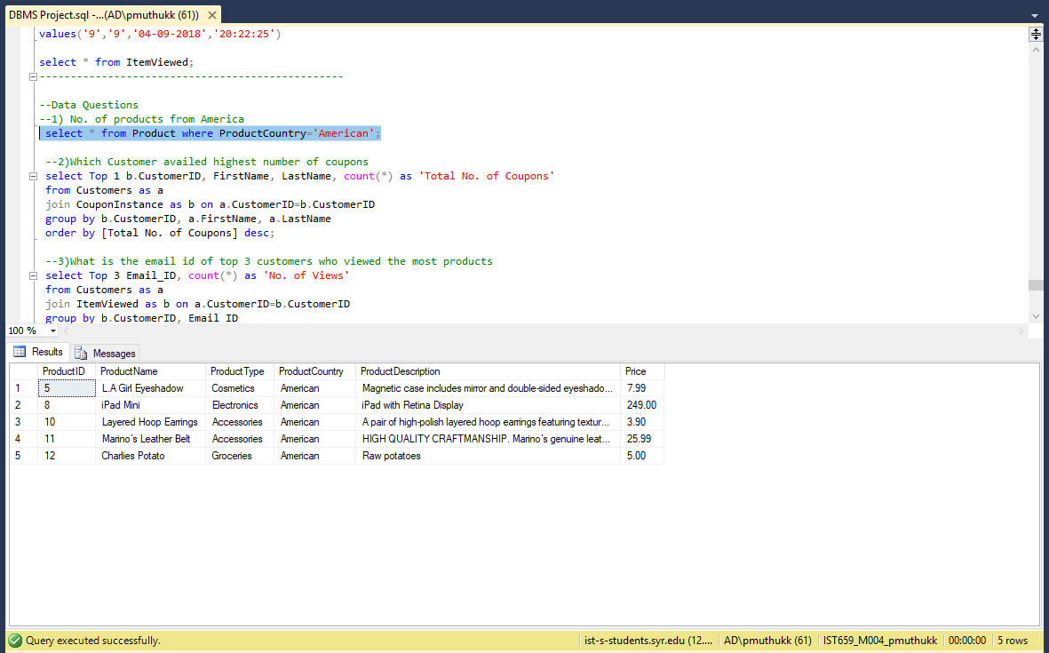

2. which customer availed the highest number of coupons

select Top 1 b.CustomerID, FirstName, LastName, count(*) as 'Total No. of Coupons'

from Customers as a

join CouponInstance as b on a.CustomerID=b.CustomerID

group by b.CustomerID, a.FirstName, a.LastName

order by [Total No. of Coupons] desc; 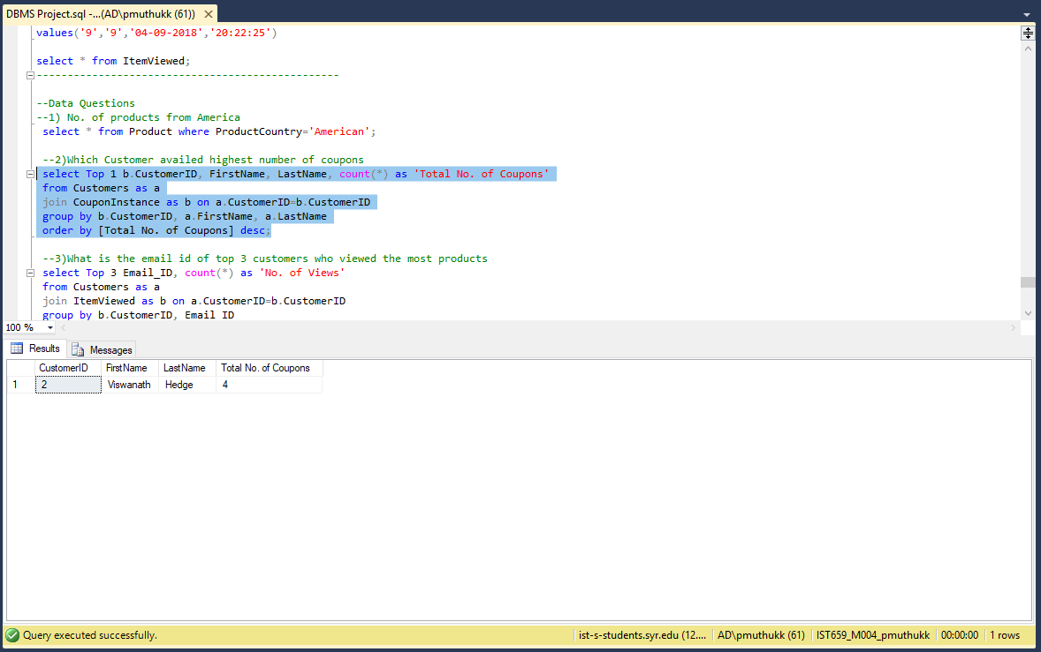

3.What is the email id of top 3 customers who viewed the most products

select Top 3 Email_ID, count(*) as 'No. of Views'

from Customers as a

join ItemViewed as b on a.CustomerID=b.CustomerID

group by b.CustomerID, Email_ID

order by [No. of Views] desc;

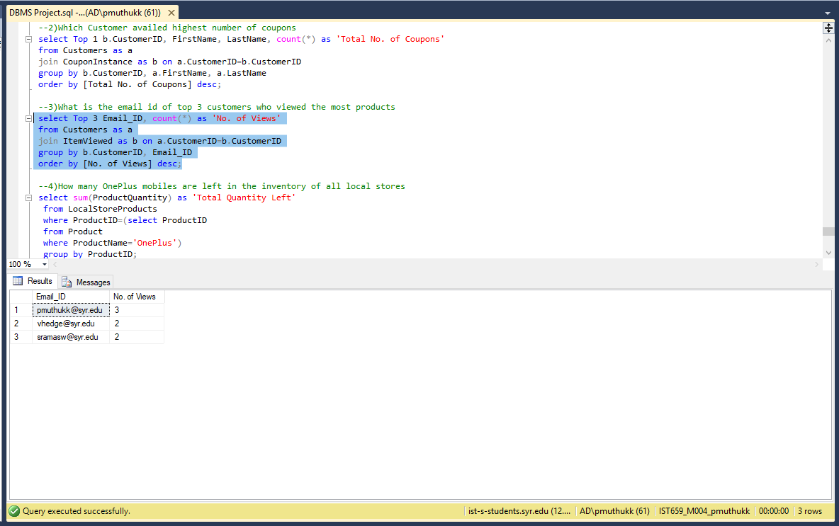

4.How much of Oneplus mobile phone is left in the inventory across all local stores

select sum(ProductQuantity) as 'Total Quantity Left'

from LocalStoreProducts

where ProductID=(select ProductID

from Product

where ProductName='OnePlus')

group by ProductID;

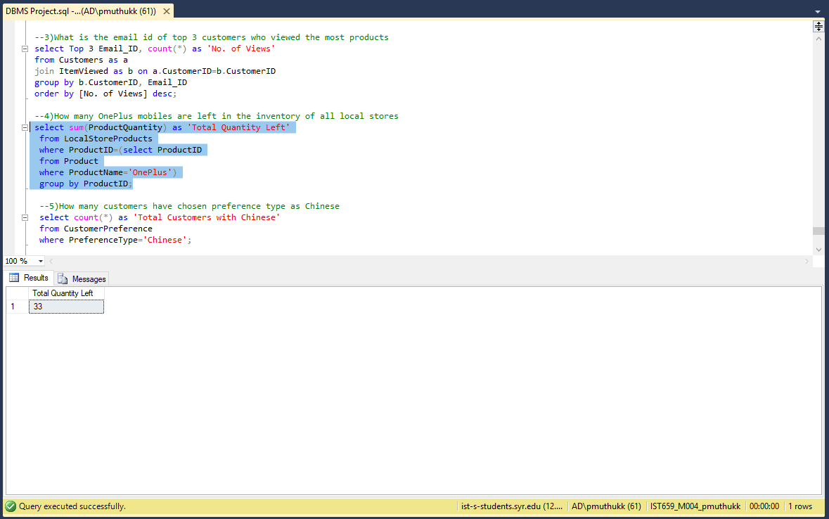

5.How many customers are there who have preference for chinese products

select count(*) as 'Total Customers with Chinese'

from CustomerPreference

where PreferenceType='Chinese';

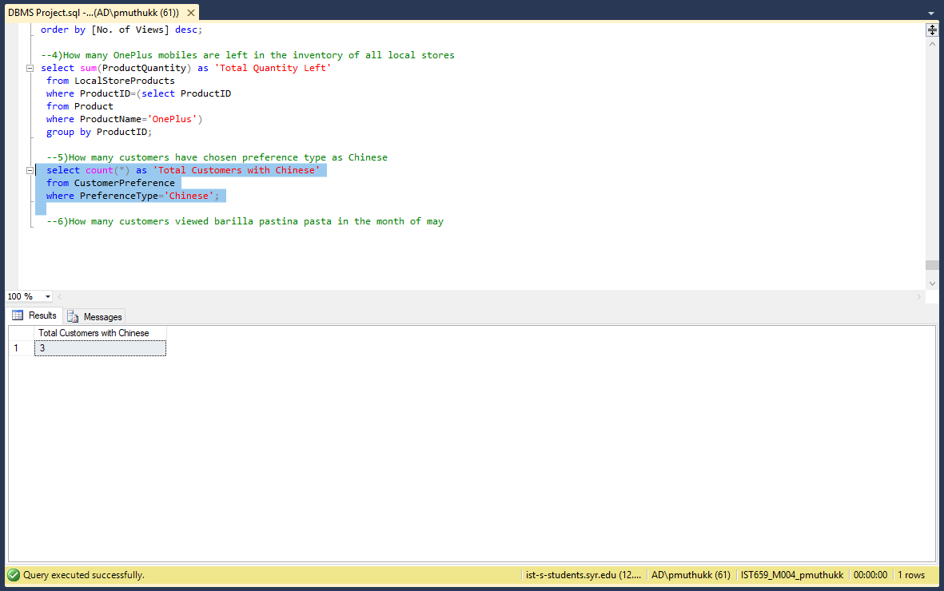

6**.**How many customers viewed Barilla Pastina Pasta in month of April

select count(*) as 'No. of Customers Viewed'

from ItemViewed

where ProductID='9' and DateViewed like '2018-04-__';

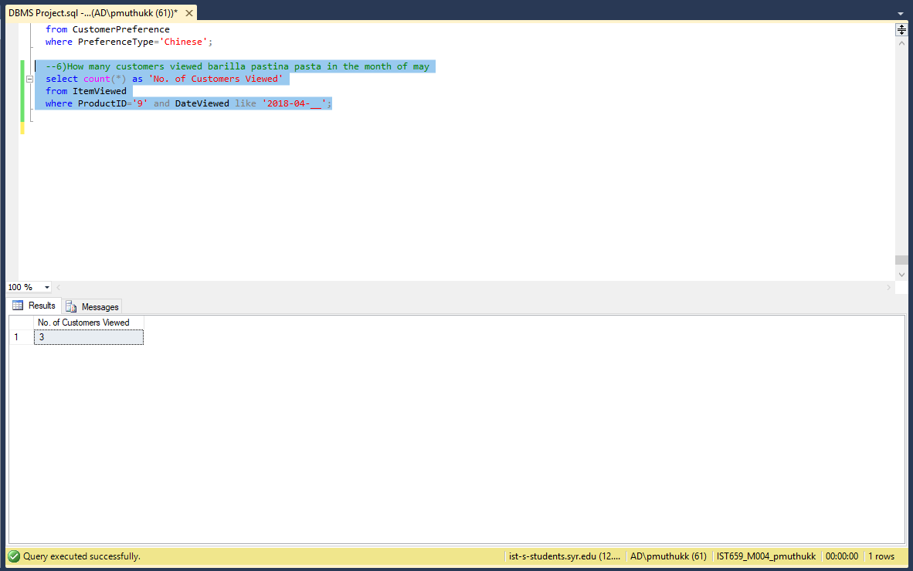

**Section 7**

**Interfaces**

**Forms:**

1. **Customers**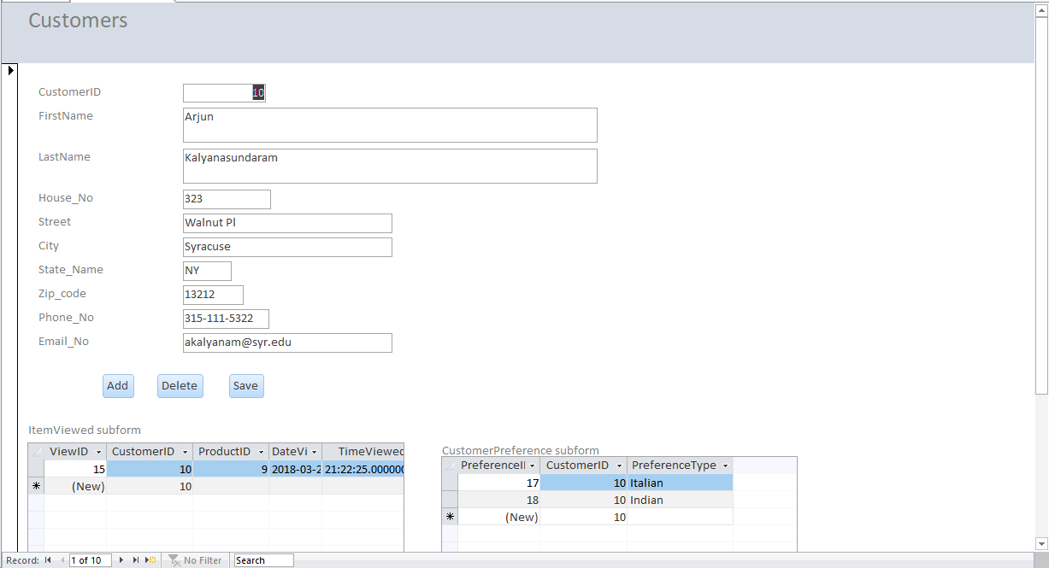

Customer form will have item viewed and customer preference as subform.

1. **Local Stores**

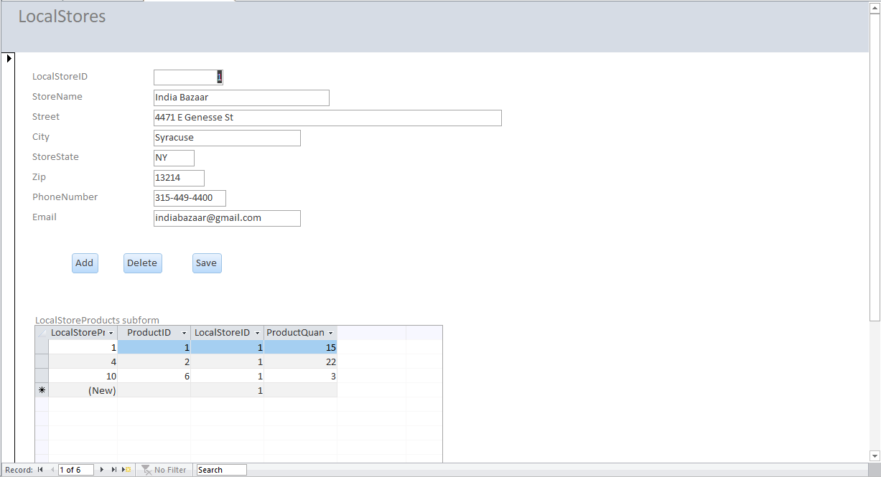

Local stores will have local store products as subform

1. **Coupon**

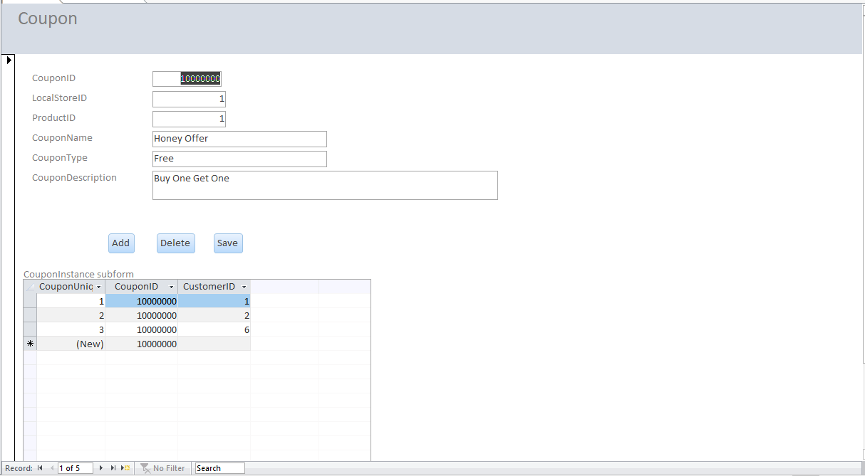

1. **Product**

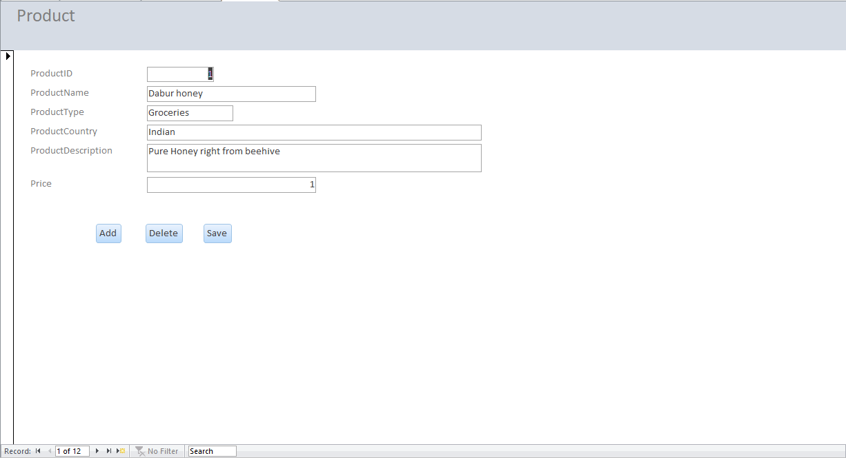

**INTERFACE**

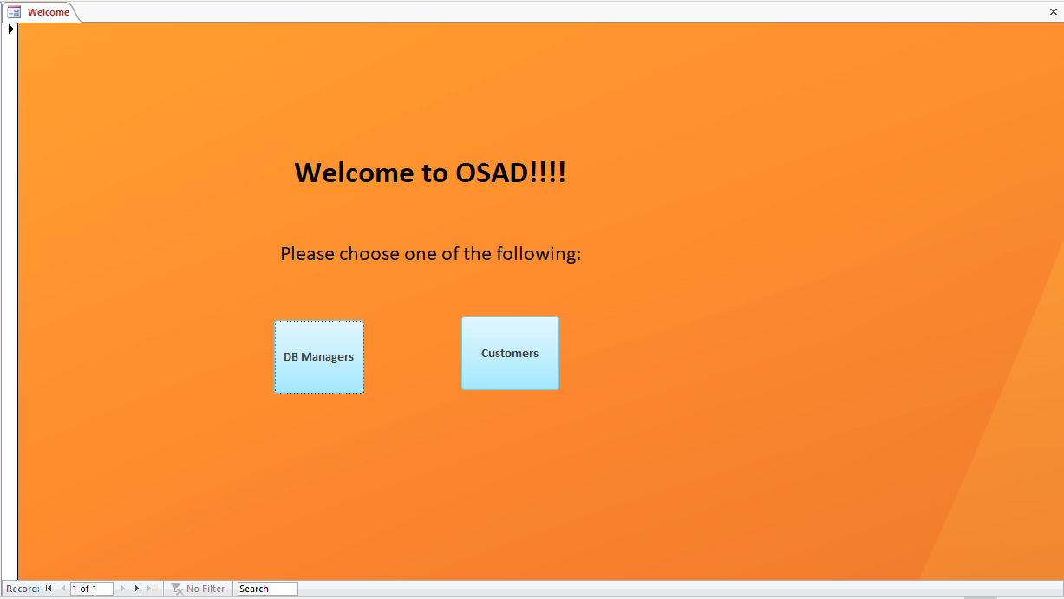

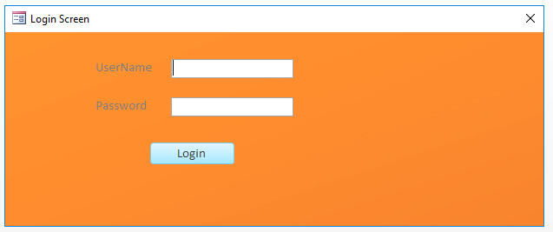 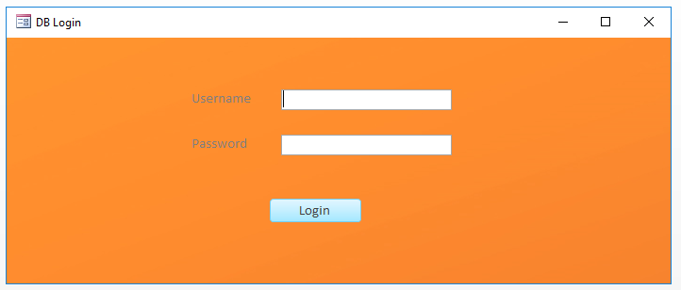

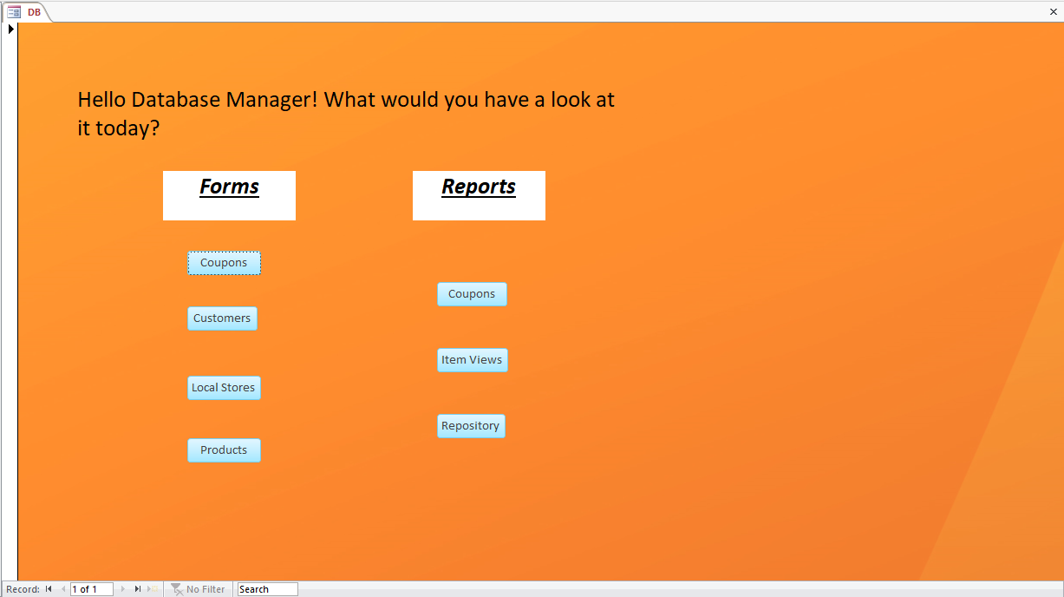

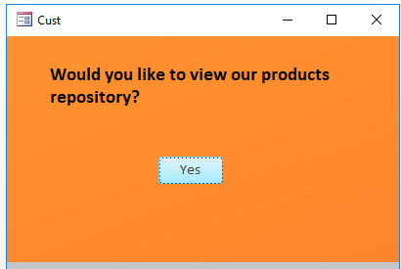

**VIEWS**

--View for products

create view product_view as

select ProductName, ProductType, ProductCountry, ProductDescription, Price,

StoreName, PhoneNumber, Email,

ProductQuantity

from Product as a

left join LocalStoreProducts as b on a.ProductID = b.ProductID

left join LocalStores as c on b.LocalStoreID=c.LocalStoreID;

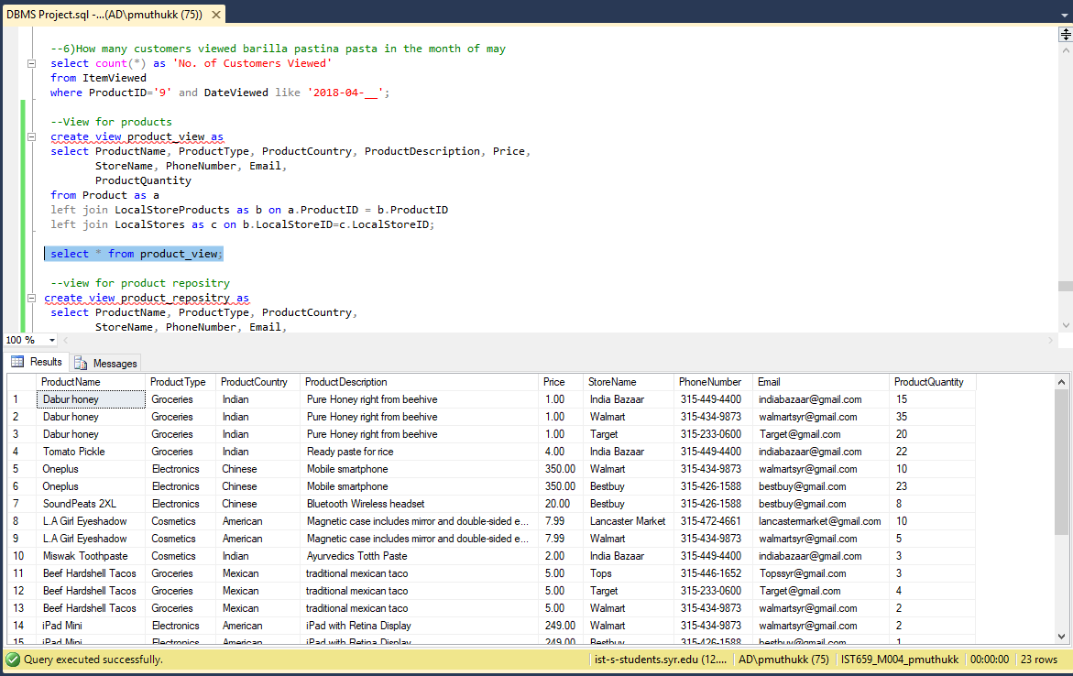

--view for product repositry

create view product_repositry as

select ProductName, ProductType, ProductCountry,

StoreName, PhoneNumber, Email,

ProductQuantity

from Product as a

left join LocalStoreProducts as b on a.ProductID=b.ProductID

left join LocalStores as c on b.LocalStoreID=c.LocalStoreID;

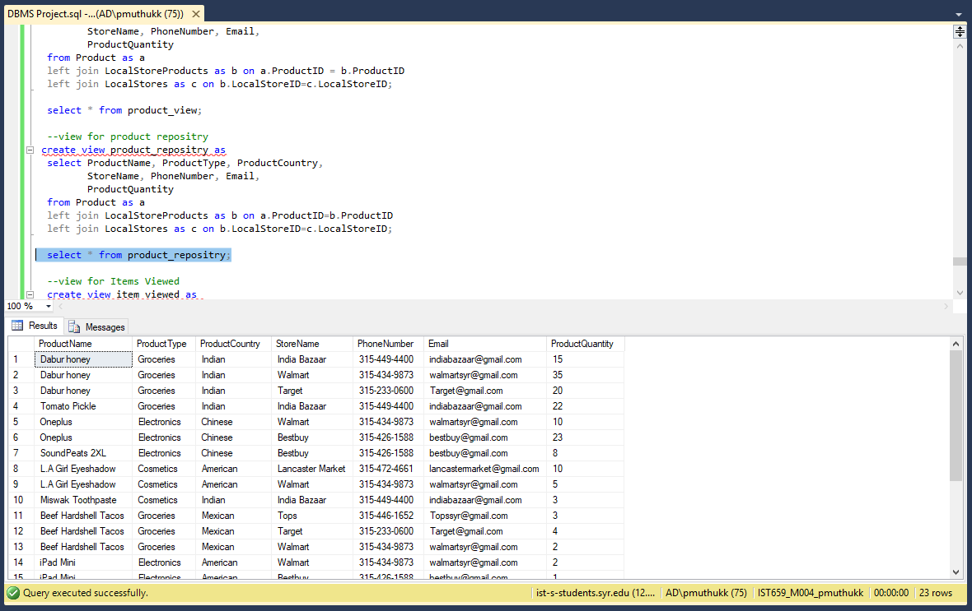

--view for Items Viewed

create view item_viewed as

select CONCAT(FirstName,' ',LastName) as 'Customer Name', Phone_No, Email_ID,

ProductName, ProductType, ProductCountry,

DateViewed, TimeViewed

from ItemViewed as a

left join Customers as b on a.CustomerID=b.CustomerID

left join Product as c on a.ProductID=c.ProductID;

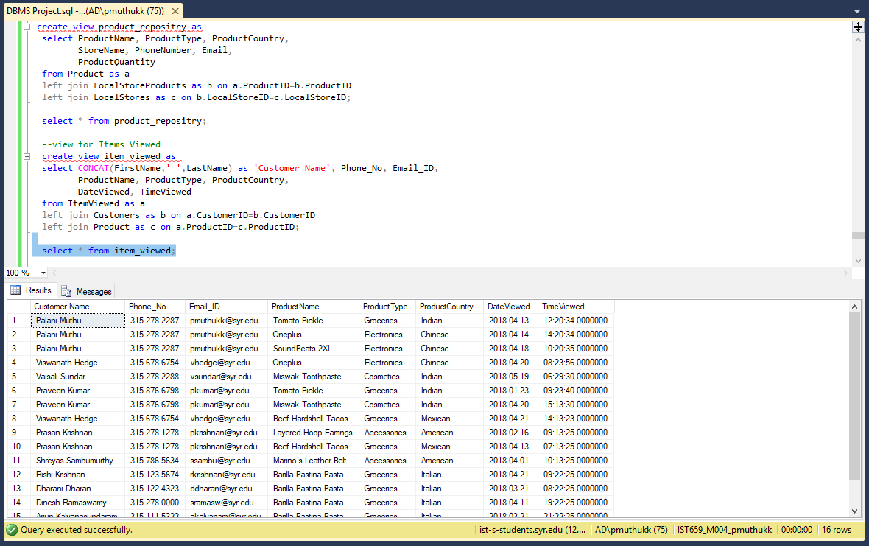

--View for coupons

create view Coupon_details as

select a.CouponID, Concat(FirstName,' ',LastName) as CustomerName, Phone_No, Email_ID,

StoreName, CouponName, CouponType, CouponDescription,

ProductName, ProductType

from CouponInstance as a

left join Customers as b on a.CustomerID=b.CustomerID

left join Coupon as c on a.CouponID=c.CouponID

left join LocalStores as d on c.LocalStoreID=d.LocalStoreID

left join Product as e on c.ProductID=e.ProductID;

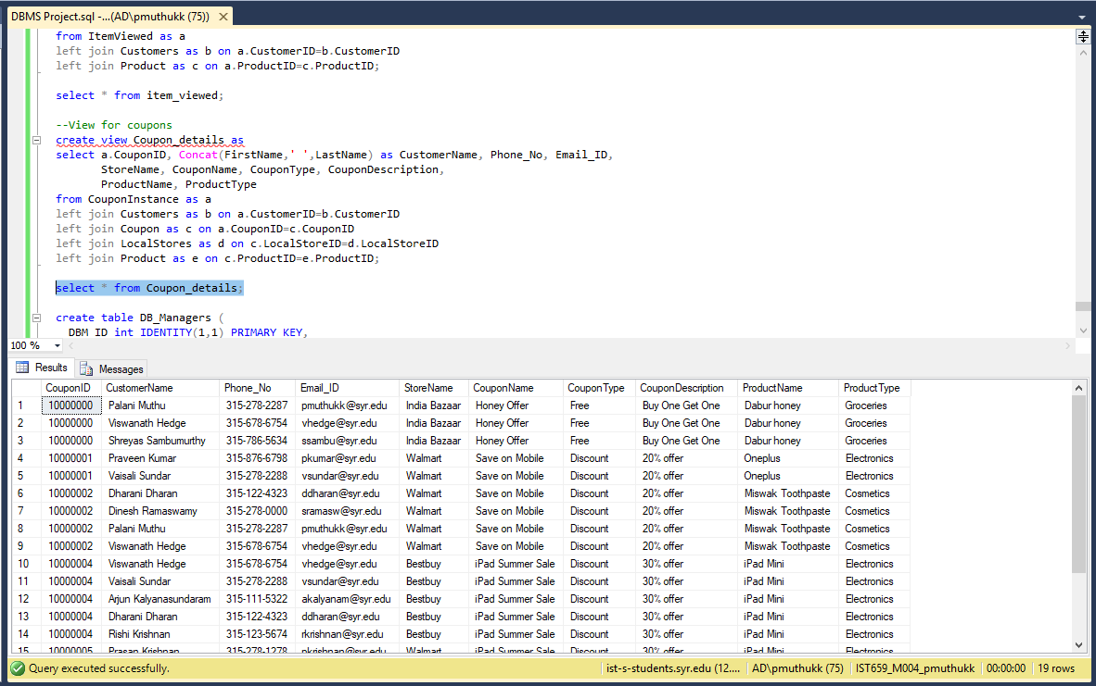

create table DB_Managers (

DBM_ID int IDENTITY(1,1) PRIMARY KEY,

FirstName varchar(50) not null,

LastName varchar(50) not null,

Username varchar(50) not null unique,

Password varchar(50) not null,

);

**Reports**

**Coupons:**

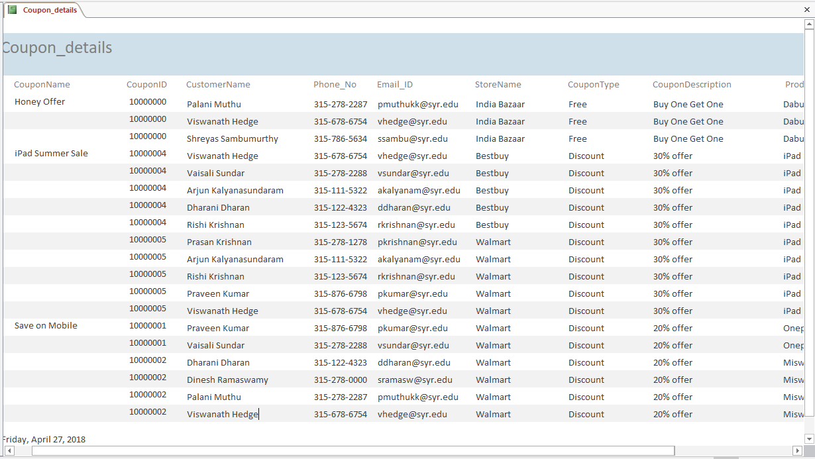

**Item Viewed:**

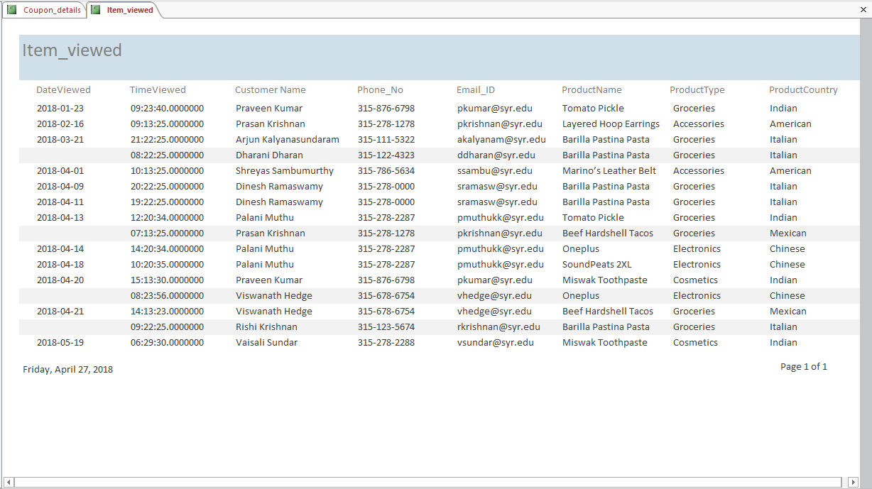

**Product Repository(DB Admin):**

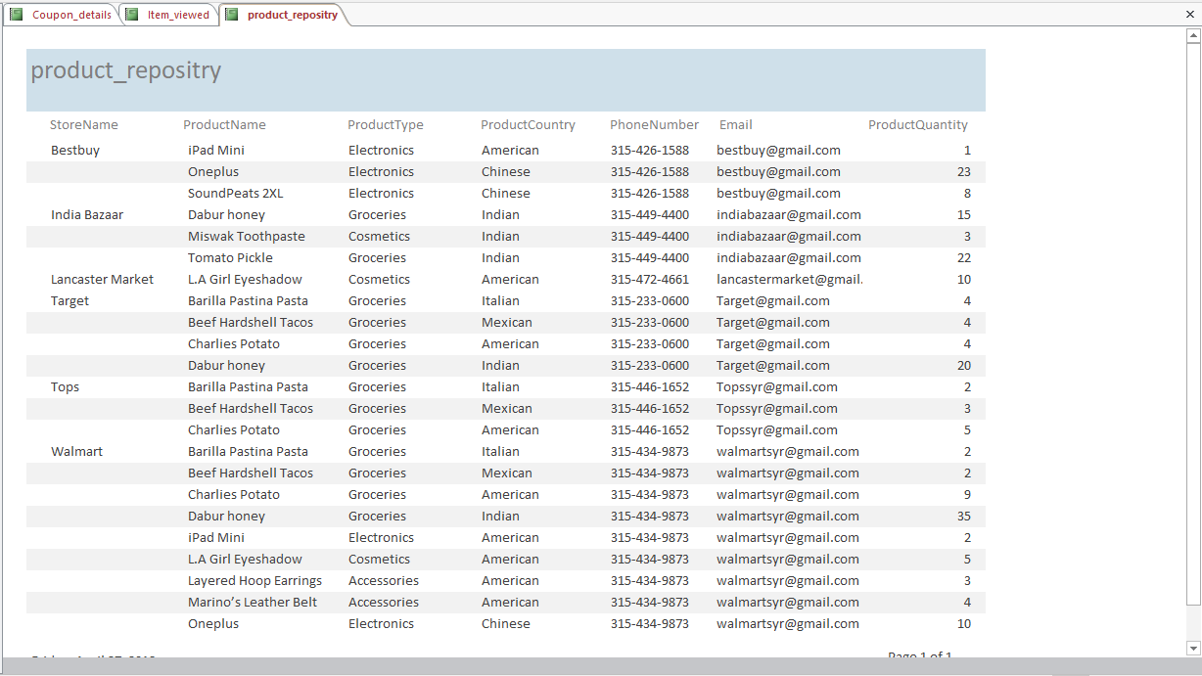

**Products:**

